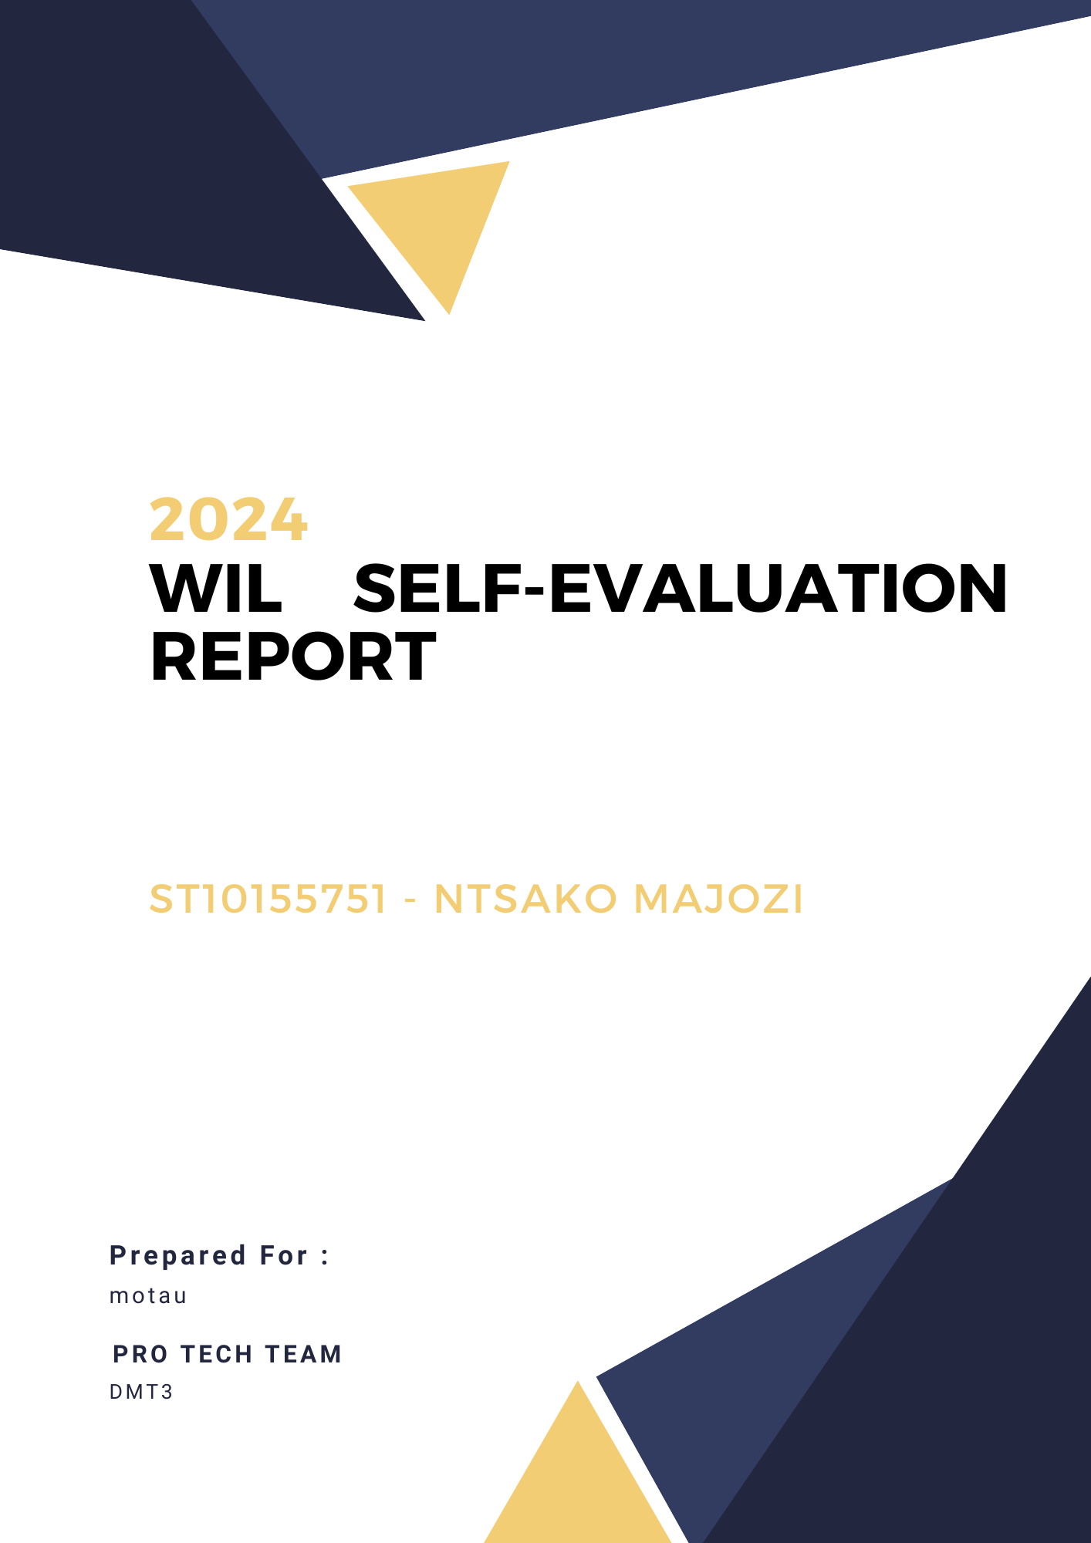

Introduction

Work Integrated Learning links classroom theory to the real-world through hands-on practice. It offers the chance to improve interpersonal skills, acquire industry-relevant skills, and gain firsthand knowledge of workplace dynamics. WIL aims to improve employability while fostering both professional and personal development.

Skills learned

I participated in a variety of team exercises, including staff meetings, brainstorming sessions, and feedback sessions. These exchanges helped my capacity for active listening, and clear communication, all of which were critical for group tasks.

Throughout my WIL, time management was critical. I showed problem-solving skills under duress by efficiently prioritizing activities to meet deadlines and rapidly adapting to resolve unforeseen challenges.

Role in the Team

I worked closely with my teammates and reported to Maduvha as a member of my team. My responsibilities included both learning and contributing. I oversaw ensuring that everyone had a task to accomplish, and I actively supported the team's goals by making sure that assignments were finished quickly.

Research, Technology, and Presentation of Information

I carried out research for the network diagram and overview in WIL. I obtained information from internet resources, and trustworthy internet databases. I clearly arranged and presented this data using tools like MS Word document enabling the team to make defensible choices.

Personal Strengths and Weaknesses

Strengths:

I demonstrated strengths in organization, analytical thinking, adaptability, teamwork, and effective communication during my WIL experience.

Weaknesses:

A few tasks proved difficult, e.g., working under pressure. To get better, I intend to look for training in these areas and create plans to deal with comparable difficulties with greater assurance in the future.

Stakeholder Relationship

I had a relationship with the WIL Coordinator/mentor that was encouraging. Seeking advice was made simple by effective communication. I want to continue being more aggressive in my communication going forward to build even more solid mentor ties.

Impact

I think that the group benefited from my contributions, which include supporting a team objective. My dependability and team support helped my members, which promoted unity and efficiency within the team.

Conclusion

In conclusion, I gained a thorough awareness of workplace standards, and the abilities I will need for my future profession thanks to my WIL experience. My technical and interpersonal abilities improved, I learned how to handle professional situations, and my career objectives were cemented as a result of the experience.